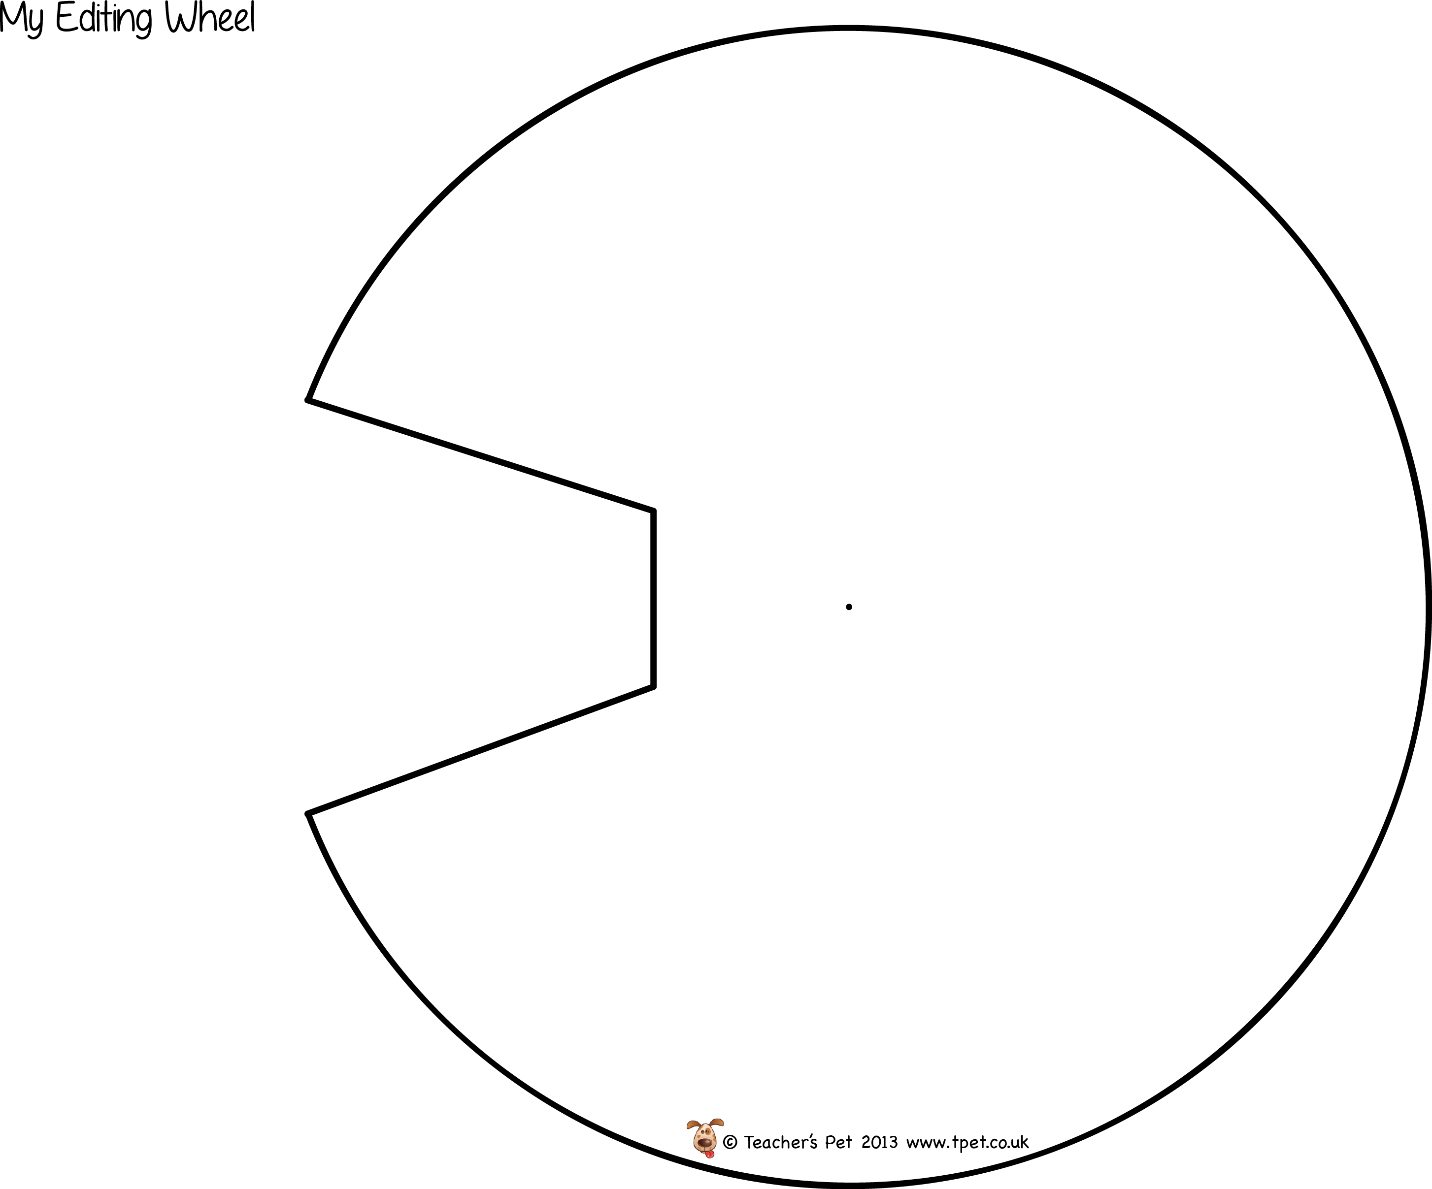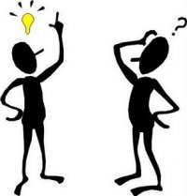

Tutoring Children and Youth Workshop

Editing Written

Material

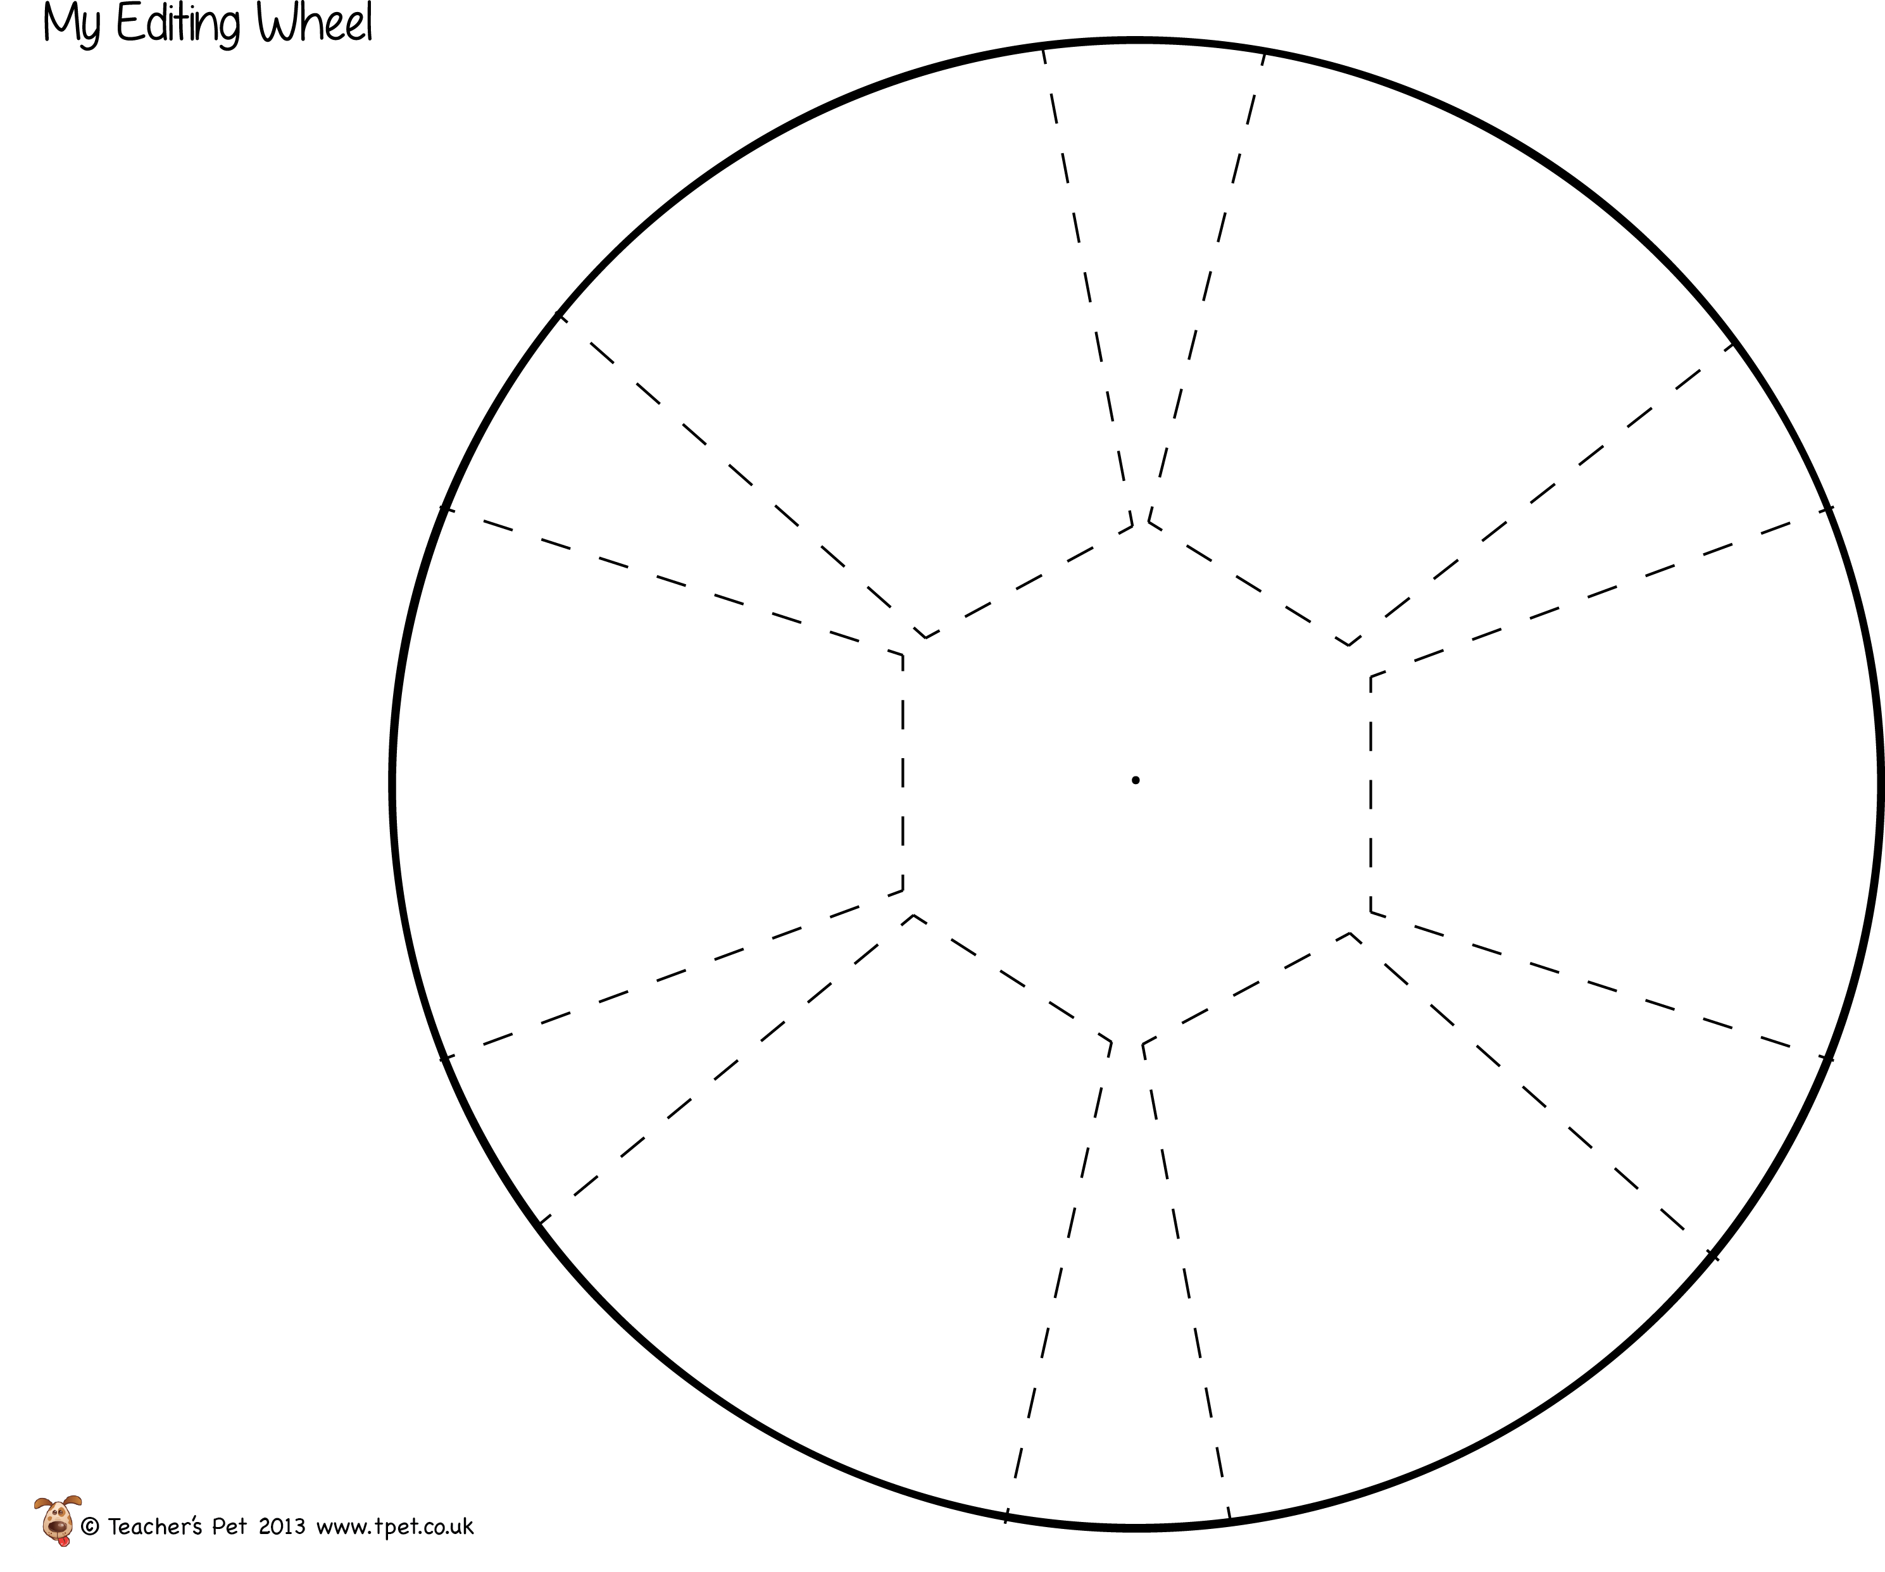

**Beginning and Ending**

* Topic sentence and closing sentence
* Introduction and concluding paragraph

**Usage and Grammar**

* Subject and verbs match
* Run on sentences
* Incomplete sentences

**Capital letters**

* Beginning sentences
* Proper nouns
* Titles

**Punctuation**

* End of sentence
* Commas
* Quotation marks
* Apostrophes

**Spelling**

* Commonly misspelled words
* Names, cities, etc.

**Is each paragraph indented?**