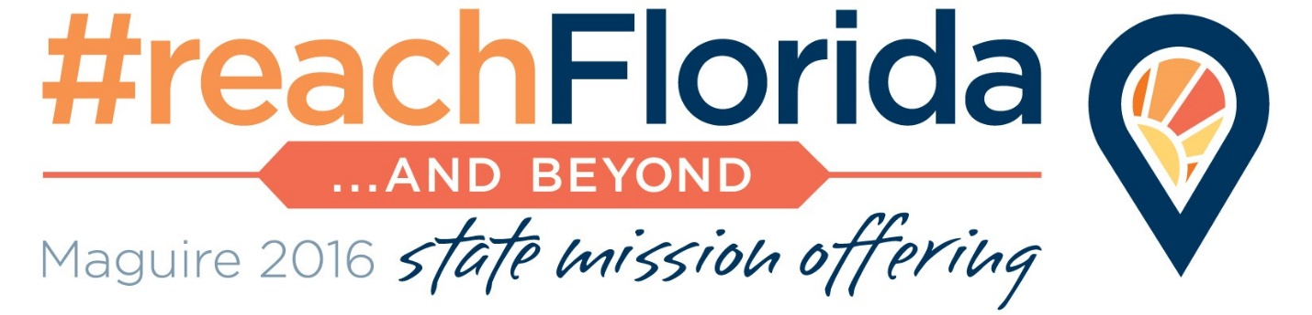

Haiti: ‘too close for Florida Baptists to ignore’
Ministry supported by state offering

Haiti--the poorest country in the Western Hemisphere. Where 10 million people live in an area smaller than the state of Maryland and the Satanic voodoo religion holds the hearts of men, women and children.
It is a place that Florida Baptists in response to their Great Commission calling to “Reach Florida and Beyond” have planted their lives and ministry for the past 20 years.
“There are needs everywhere, but the needs in Haiti are vast,” said James Peoples, pastor of the Trinity Baptist Church in Keystone Heights.
“It is just 700 miles from the shores of Florida and God has opened the door for us to come and make a difference by bringing the light of Jesus Christ in this dark place,” Peoples added.
“The Lord has opened the doors for Florida Baptists to make a difference,” said Peoples, who also serves as the president of the Florida Baptist State Convention and recently traveled to the nation.
Two decades after the start of the partnership between Florida and Haitian Baptists, Mike Tatem, president of the State Board of Missions, said he can see the contributions no one else is making in the country.
“Florida Baptists can be confident we have made a difference with the Gospel in this place,” he said.
Twenty years ago, Florida Baptists began impacting Haiti by partnering with 36 new churches planted by Haitian churches in Florida.
That small nucleus of churches was given structure, organization and indigenous leadership drawn from the group of churches.
Organized as the Confraternite Missionaire Baptist d’Haiti, the Convention led the churches to focus on church planting, evangelism and church development as key components to the mission.
Now the three dozen churches have grown to 1,726 congregations with 184,678 members and 335,500 in worship attendance. In 2015, CMBH churches planted 110 new congregations, led 59,324 people to Christ and baptized 35,557 new believers.
And throughout the two decades, Florida Baptists have responded after hurricanes, floods and the 2010 earthquake with beans and rice for the hungry, temporary and permanent shelters for the homeless and medical care for the injured.
Craig Culbreth, lead catalyst of the Convention’s Missions and Ministries Group, estimates that 12,000 to 15,000 Florida Baptists have participated in mission trips to Haiti across the 20 years.
“Of course, the highest number of volunteers came in 2010 through 2012 in response to the devastating earthquake. We had as many as 1,000 volunteers a year during those three years,” said Culbreth. Currently, on average, 50 teams with 500 volunteers serve in Haiti each year.
During the past year, 186 Haitian pastors graduated from theological education classes provided by the Florida Convention and New Orleans Baptist Theological Seminary. The graduation ceremonies held in September, marked the 20th anniversary of the Florida-Haiti partnership
“For us this is a great day,” said Pastor DeLouis Labranche, CMBH’s director of ministry, his excitement shining in his eyes and brimming in his voice. “It is the 20th anniversary of the CMBH, formed in 1995, and then we will graduate 186 students from NOBTS.”
For Labranche, the day’s activities were a “testimony” to the rest of the country, he said, that the Gospel is more powerful than the satanic voodoo religion that holds the hearts of the majority of the 10 million Haitians.
“The spiritual warfare in Haiti is very real,” added Tommy Green, executive director-treasurer of the Florida Baptist Convention, who traveled to Haiti for the anniversary celebration and graduation. “Indeed there is voodoo and there is spiritual darkness found around the country in Haiti.
“As these pastors take their stands for Christ in their community, they are battling against a very present force,” he added.
Haitian pastors have no other opportunities “to find quality theological education,” Green explained. “So through the regimen of classes they have acquired elements of pastoral ministry to better equip them, to better equip their churches and other pastors and become more effective in ministering to their communities and cities.”
The ministry would not have been accomplished without funds from the Maguire State Mission Offering, which provided the primary support to enable Florida Baptists to impact the nation of Haiti. Each year, funds have been allocated to underwrite the international ministry. In the 2016 offering, $120,000 is earmarked for the ministry.
The ministry is unsustainable without the resources from the Maguire State Mission Offering.
“I encourage Florida Baptists to give as generously as they can to the Maguire State Mission Offering. The offering is being invested in Haiti and is making a difference,” said Peoples.
“Lives are being touched. Souls are being saved. Disciples are being made for Jesus Christ in Haiti because of your gifts.”

